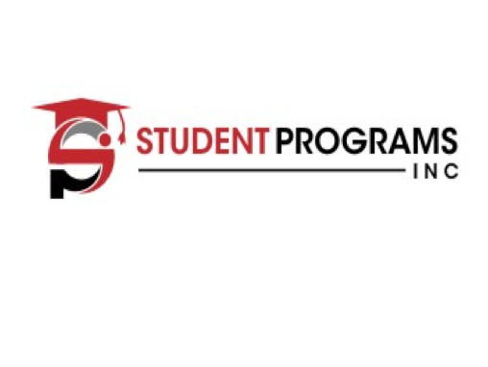

J1 Intern/Trainee Program

About SPI:
Student Programs Inc. (SPI) provides educational enrichment programs to students worldwide. SPI has been offering academic programs for 30 years. Our directors and staff members dedicate themselves to offering the finest in classes, activities, workshops, and excursions. SPI stands alone, because our staff create an atmosphere that provides students with the resources, guidance and attention they deserve.

J1 Internship/Trainee Program:
This program offers university students, recent graduates, and young professionals the opportunity to come to the United States and take part in an internship or training program. Candidates will gain exposure to American culture and receive hands-on experience in U.S. business practices in their chosen occupational field/industry. Candidates will receive supervision and evaluation from staff within each host company. SPI will monitor the program and work with the candidate and host company. Candidates are encouraged to travel and experience American cultural activities and experiences during their free time. The purpose of the program is for candidates to gain professional development and cultural understanding.

Program Goals
SPI provides candidates and host organizations the opportunity to engage in a valuable cultural exchange program. An important goal of this program is that participants will return to their home countries and share their experiences with their fellow citizens.

Participation on the program will meet the following objectives:
- Introduce international professionals to U.S. culture and business practices by living and training
alongside American colleagues;
- Provide international professionals the opportunity to develop their skills with hands-on application in their
occupational field; and
- Provide a unique cultural exchange experience.

Eligibility:
Intern Eligibility:
- A foreign national who is currently enrolled in an accredited academic post-secondary degree/certificate program outside of the U.S. in their occupational field,
OR
- A foreign national who graduated from an accredited academic post-secondary degree/ certificate program outside of the U.S. in their occupational field no more than 12 months prior to their requested DS-2019 start date.

Trainee Eligibility:
- A foreign national who graduated from an accredited academic post-secondary degree/ certificate program outside of the U.S. in their occupational field more than 12 months before their requested DS-2019 start date AND has at least 1 year of related full-time work experience outside of the U.S.
OR
- A foreign national who did not graduated from an accredited academic post-secondary degree/certificate program outside of the U.S. but has at least 5 years of related full-time work experience outside of the U.S.

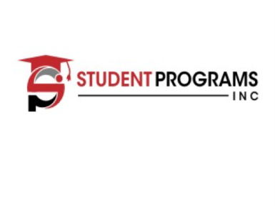

J1 Intern/Trainee Program

Program Includes:
- Review of Application materials, Requirements and Documents
- Paid Placement
- Creation of the Training Internship Placement Plan
- Orientation Materials Prior to the Program
- DS-2019 Form and Supporting Documents
- Consular Intervention and Support (as needed)
- Health Insurance Enrollment with an SPI-Approved Provider
- On-going Monitoring of the Program Experience
- Liaison between Candidate and Host Company in U.S. (as needed)
- 24-hour Emergency Support while in the U.S.

Program Duration:
Candidates’ authorization is limited to the time period indicated on their DS-2019.
- Intern Programs may not Exceed 12 months.
- Trainee Programs may not Exceed 18 months.
- All other Trainee Programs may not Exceed 18 months.

Industry Categories:
- Hospitality and Tourism
  - Food & Beverage
  - Culinary
  - Front Desk
- Business
  - Marketing
  - Business Administration
  - Ecommerce
  - Business Management
  - Business Development
- Law
- Accounting
- IT

Internship/Trainee Placement:
SPI offers customized internship placement at thousands of companies and guarantee candidates’ placements within their chosen occupational field/industry.

All intern and trainee placements are paid at least minimum wage or higher. This usually ranges from $12/hour to $20/hour for 32 to 40 hours per week.

Safety:
Candidates will be provided emergency contact information 24/7 throughout their U.S. experience. SPI directors work very closely with each candidate on the program to give them the personalized attention they deserve and to make sure each candidate feels safe and cared for during their program.

J1 Intern/Trainee Program

Required Documents from Candidate:
Application
Resume Picture Passport
University Letter/Copy of Degree Copy of Past US Visas (if applicable)

Process:
Step 1: Submit candidate’s resume and application form to SPI
Step 2: Pay deposit
Step 3: Interview with candidate
Step 4: Placement Process - scheduling interview between host company and candidate Step 5: Host Company sends offer letter to candidate
Step 6: Final payment is due
Step 7: Final works with host company and candidate to submit all required documentation to sponsor
Step 8: Sponsor will hold interview with candidate and host company. Step 9: DS 2019 issued to candidate
Step 10: Visa appointment.
Step 11: Once visa is issued, candidate comes to the US to start their program.

