Thank you for your interest in working in Yellowstone during the summer 2024 season!
Your first step is to apply online on our website! Please click here to apply.

Make sure the application says, “2024 Work and Travel Student – J-1 Visa – Yellowstone National Park, WY” and apply ONLY to this application. Click “Apply” to begin.
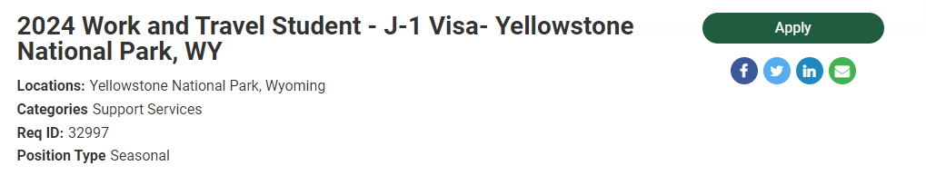
Next, type in your personal email address. Please make sure that you DO NOT USE your school email address if you will not be able to access it during summer break. After you have typed in your email address correctly, please read the privacy notice, and click the “I Understand” box when you’re done. When you have typed in your email and clicked the “I Understand” box, click the “Next” button on the bottom will turn green. Click it to continue.
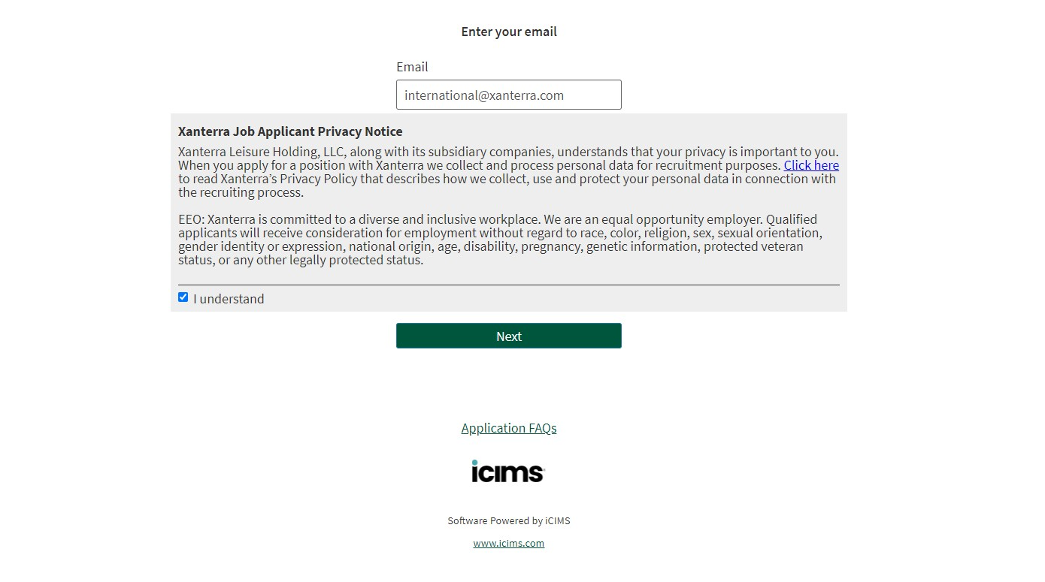

The first page is creating your account, please answer all of the questions.
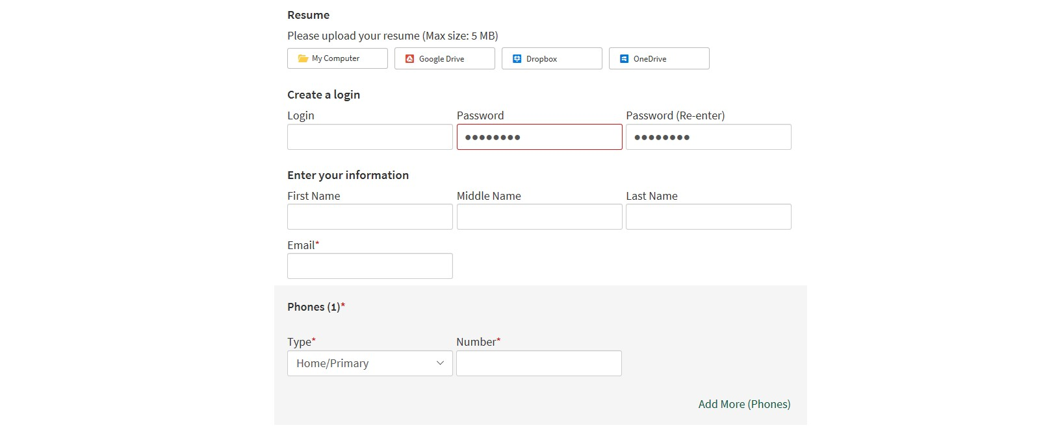
In the address section, you need to put in TWO addresses. The first address should be this:
PO BOX 165, Yellowstone National Park, WY 82190 Please use the photo below as an example:
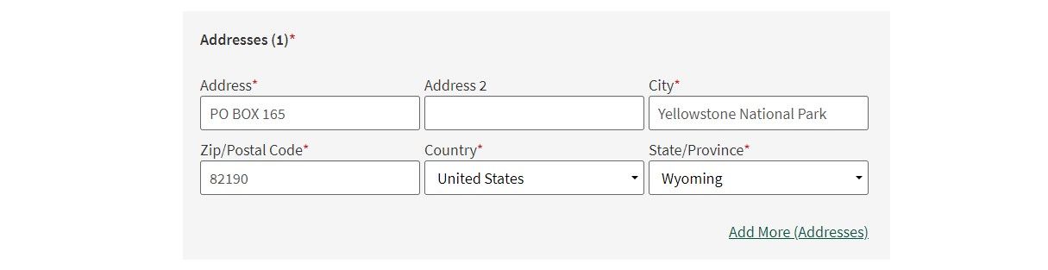

After you’ve typed in the Yellowstone address, click “Add More (Addresses)”
A second section for addresses will appear, please type YOUR home address in this section. When you select your country, the State/Province option will say “No States Available”.
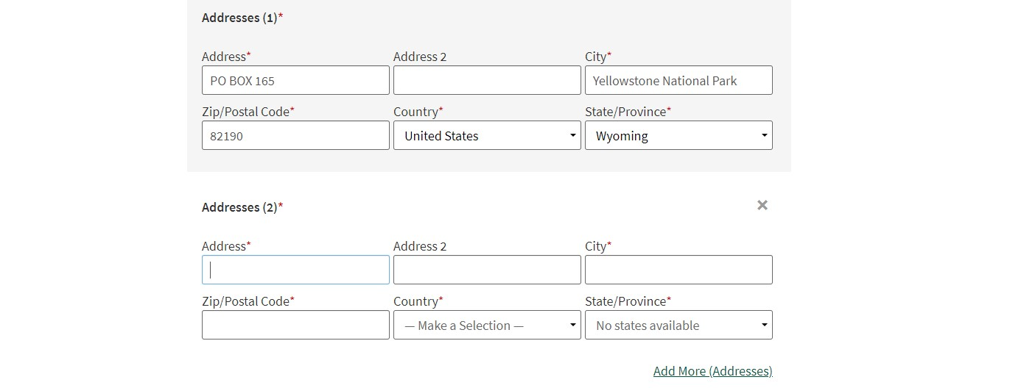
Next, you will continue answering the account questions. Make sure to select “Yes” for the U.S. work eligibility question. If you do not remember your start and end dates, that is okay. I have them written down and will only send you an offer with the dates we decided on during your interview. For “Housing Preference” please select “Dormitory Housing” and for “Desired Type of Employment”, please select “Seasonal”.
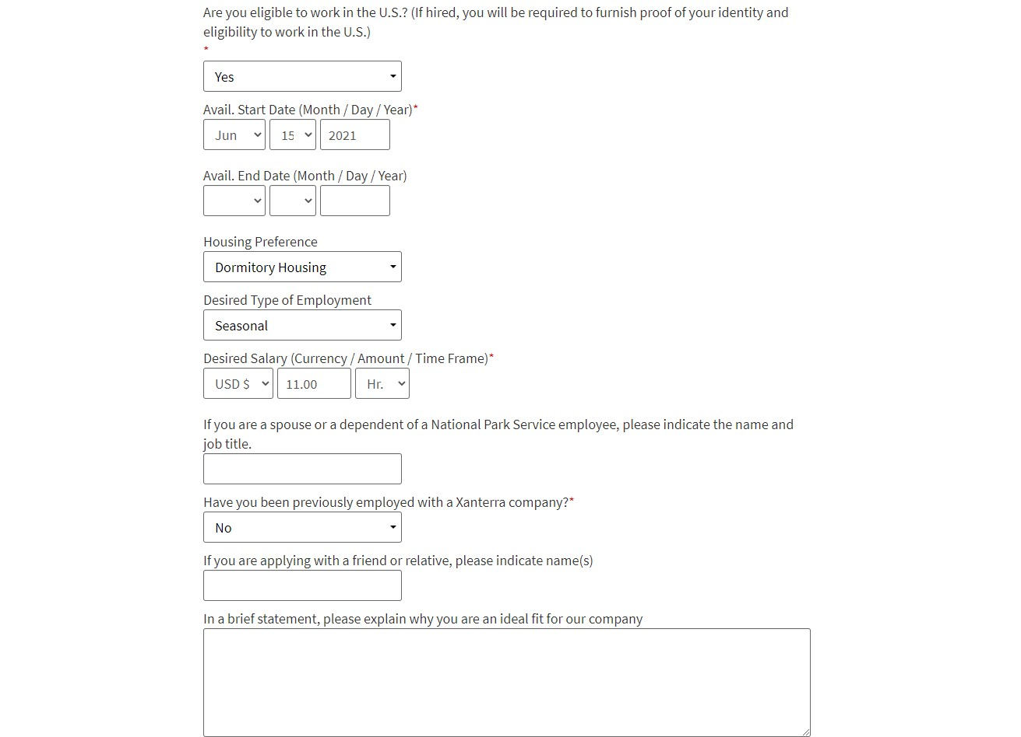
The next section is about your work history and education. You do not need to fill out these sections, we already have that information.
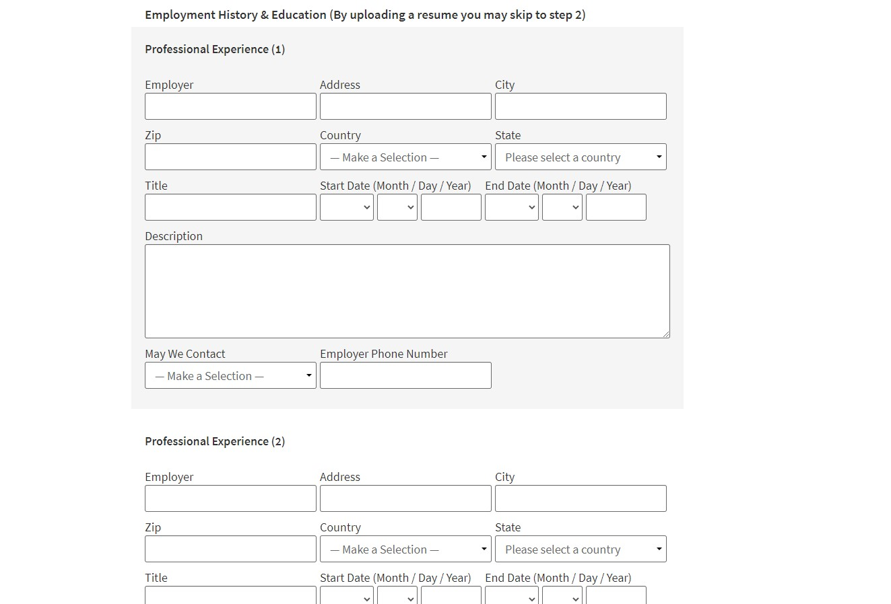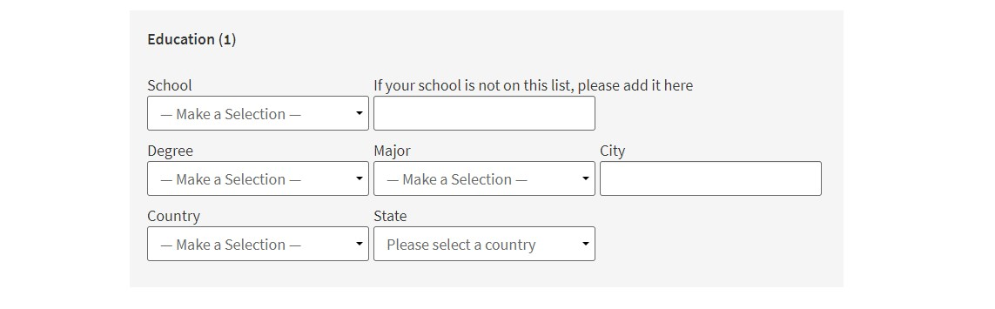
The next page asks job specific questions:
- Do you have a particular location/village at which you would prefer to work? If you know there is a village in Yellowstone you’d like to work, please write your request here. If you do not have a preference, you can skip this question.
- What U.S. sponsor are you working with for your visa? Please select if you work with Aspire, CCUSA, CIEE, or InterExchange.
- Have you worked in Yellowstone or another Xanterra Park before? Please Select Yes or no

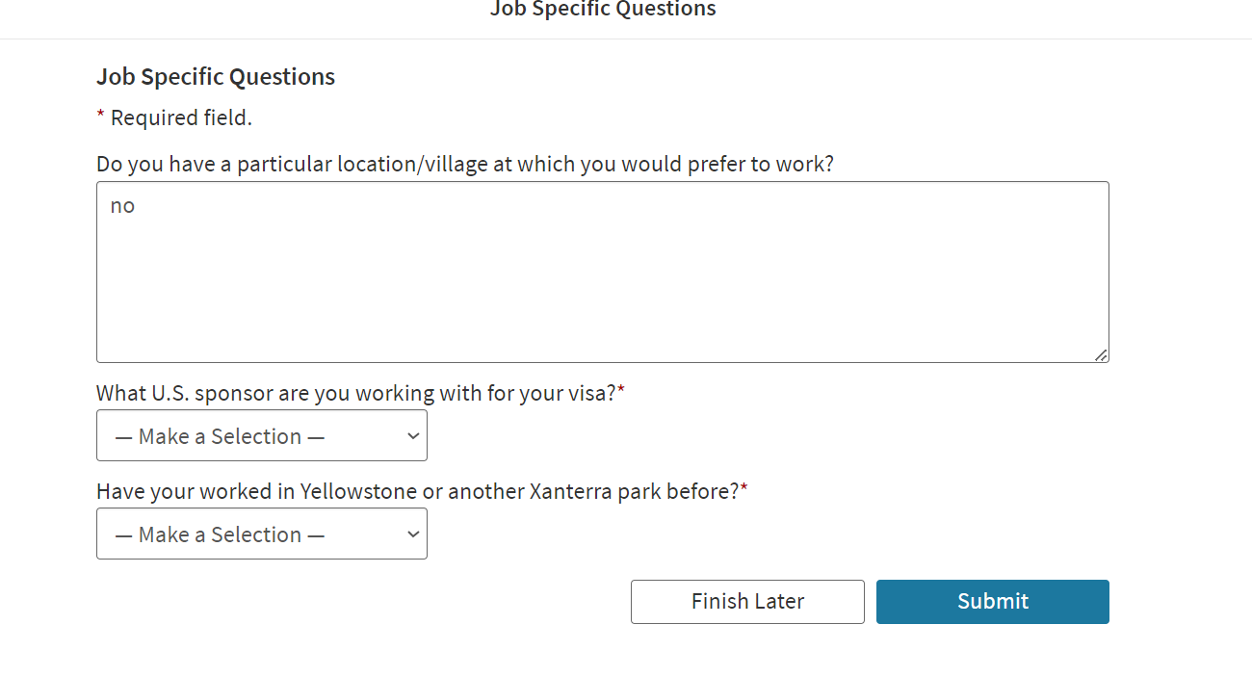
The next page will ask if you consent to receiving text messages. Please select “No”
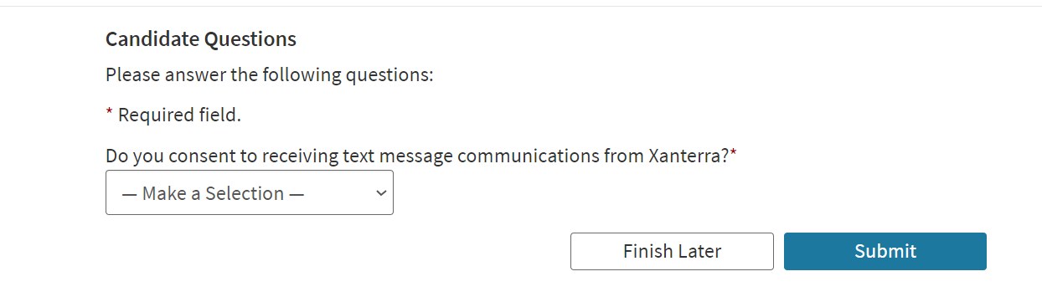
This page is asking if you have a disability, you can look at the list of disabilities and click “Yes”, “No”, or “I do not wish to answer” then make sure to click the yellow signature box below before clicking submit.
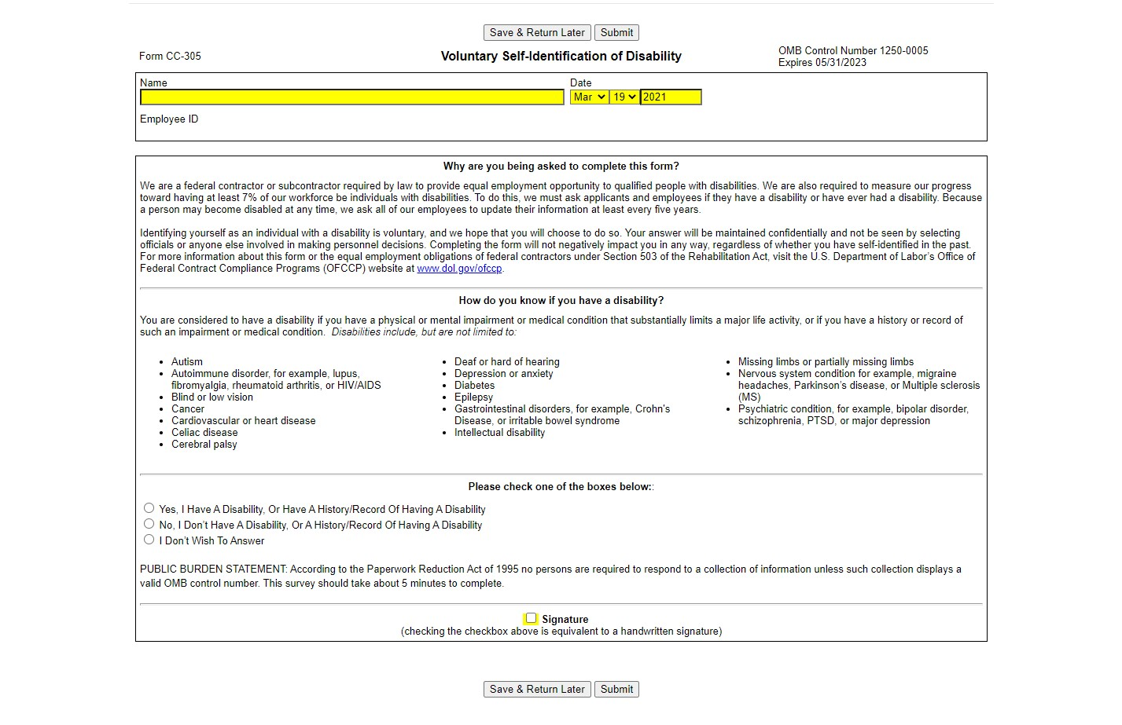

This page asks if you are a protected veteran. Everyone should click “I am not a protected veteran” or “I don’t wish to answer” unless you are a veteran of the United States. Then click the yellow signature box before clicking submit.
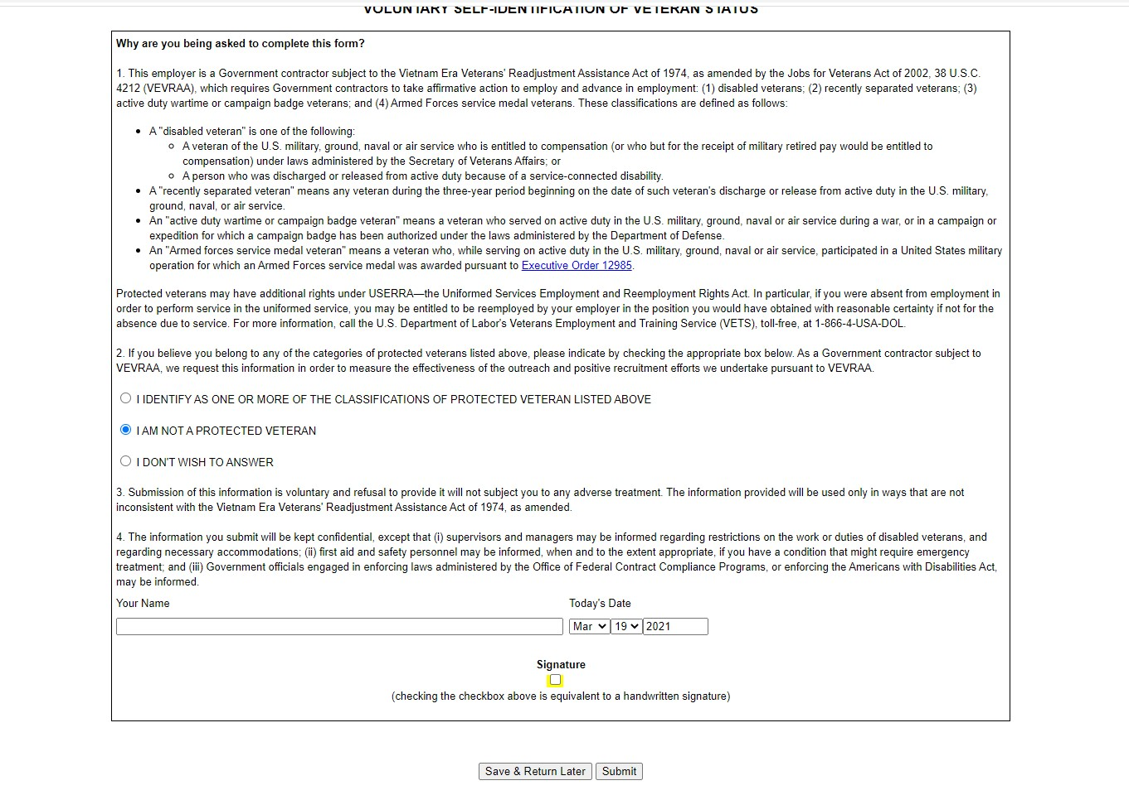

Once you have clicked submit, you should see this page with a confirmation of your application! Please take a picture or screenshot of this page just in case we cannot find your application in the future!
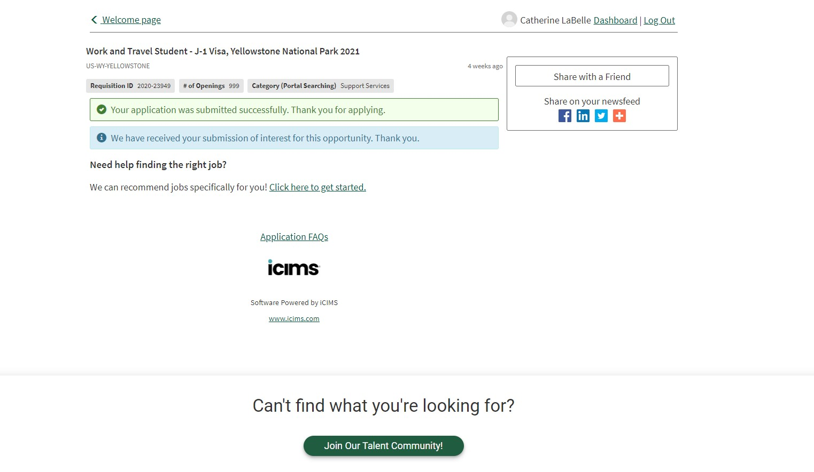
Please email clabelle@xanterra.com with any questions about your application!

