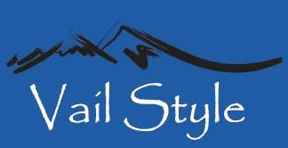

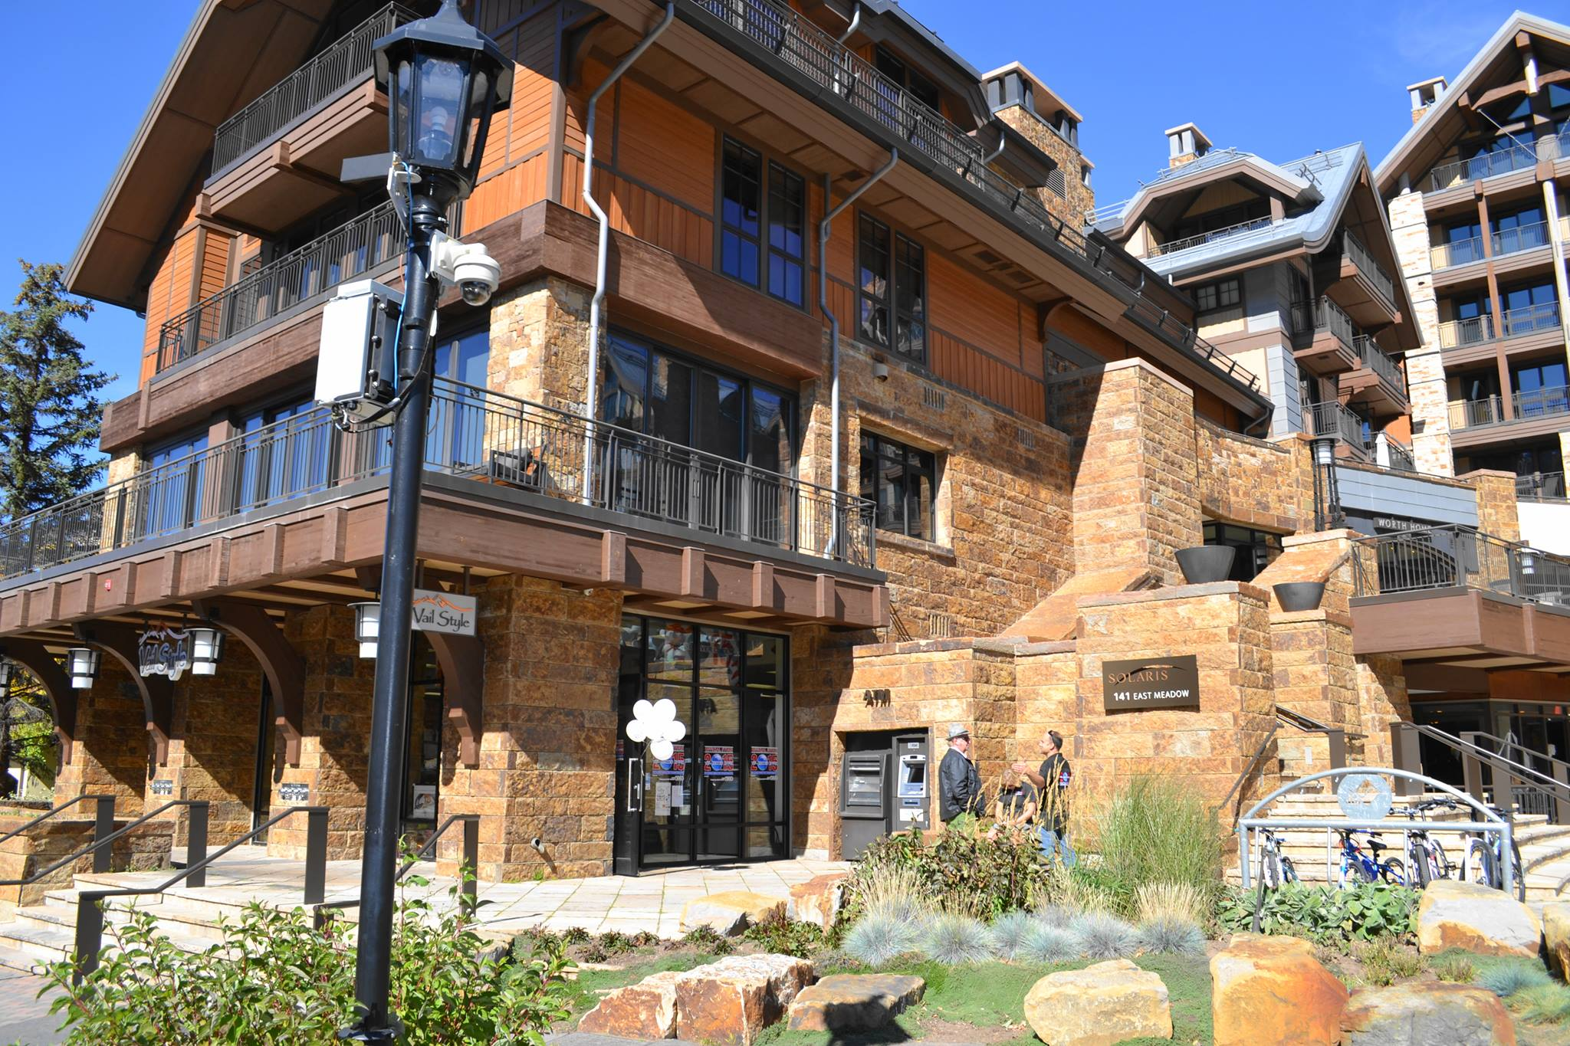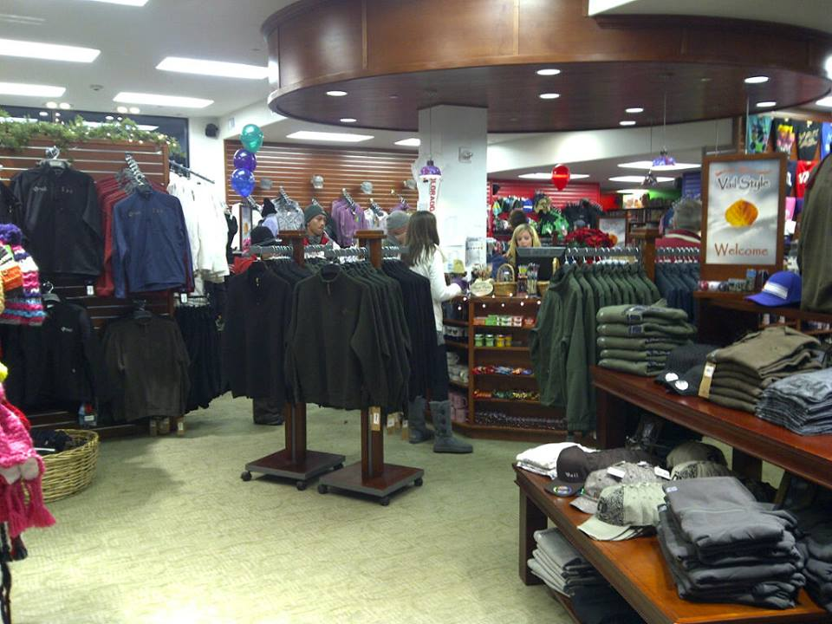

https://www.facebook.com/vailstyle/
shopskicountry.com

Employer type: |  | SHOP-RETAIL
Employer Info: |  | Small retail/souvenir shop chain with shops in Vail and Beaver Creek, Edwards
Location info: |  | Vail, Colorado  tourist cities in Colorado, very scenic, located in the mounatins.
Average h/week: |  | 32- 40
Overtime: |  | No overtime available
Position: | Job title: | Sales Associate (2 – Beaver Creek- couple preferred)
Position: | Salary: | $19.00/h
Position: | Start/ end dates: | 25.05-15.06 – 15-30.09
Position: | English knowledge: | Excellent English and great communicational skills
Position: | Additional work info: | Employee will need to interact with customers all day. Duties include: handling cash, stocking, cleaning, shipments, organizing, assisting customers with merchandise as well as helping with questions or problems.
Bonus/ benefits: |  | - You will be paid bi-weekly  - end of season bonus based on work performance,  - 50% off in 12 company stores
Additional Employer info: |  | - uniforms will be provided for FREE  - After arrival employees will have one full day off before they start working  - Three days paid training required
Housing info? |  | - YES  Full furnished housing is available for $600 (payroll deduction) per month, $200 refundable deposit ($50 deduction from four first paychecks).  Employer offers 3 convenient locations:  - for Beaver Creek employees - 4 BD 4 BA apartment ( 2 people per room ) located 3 mile from work place – free bus available  - for Vail employees:  * 2 BD 2 BA apartment ( 2 people per room ) located 2 mile from work place – free bus available  * 4 BD 3 BA townhouse ( 2 people per room ) located 4 miles from work place – free bus available

