EMPLOYER NO. 334


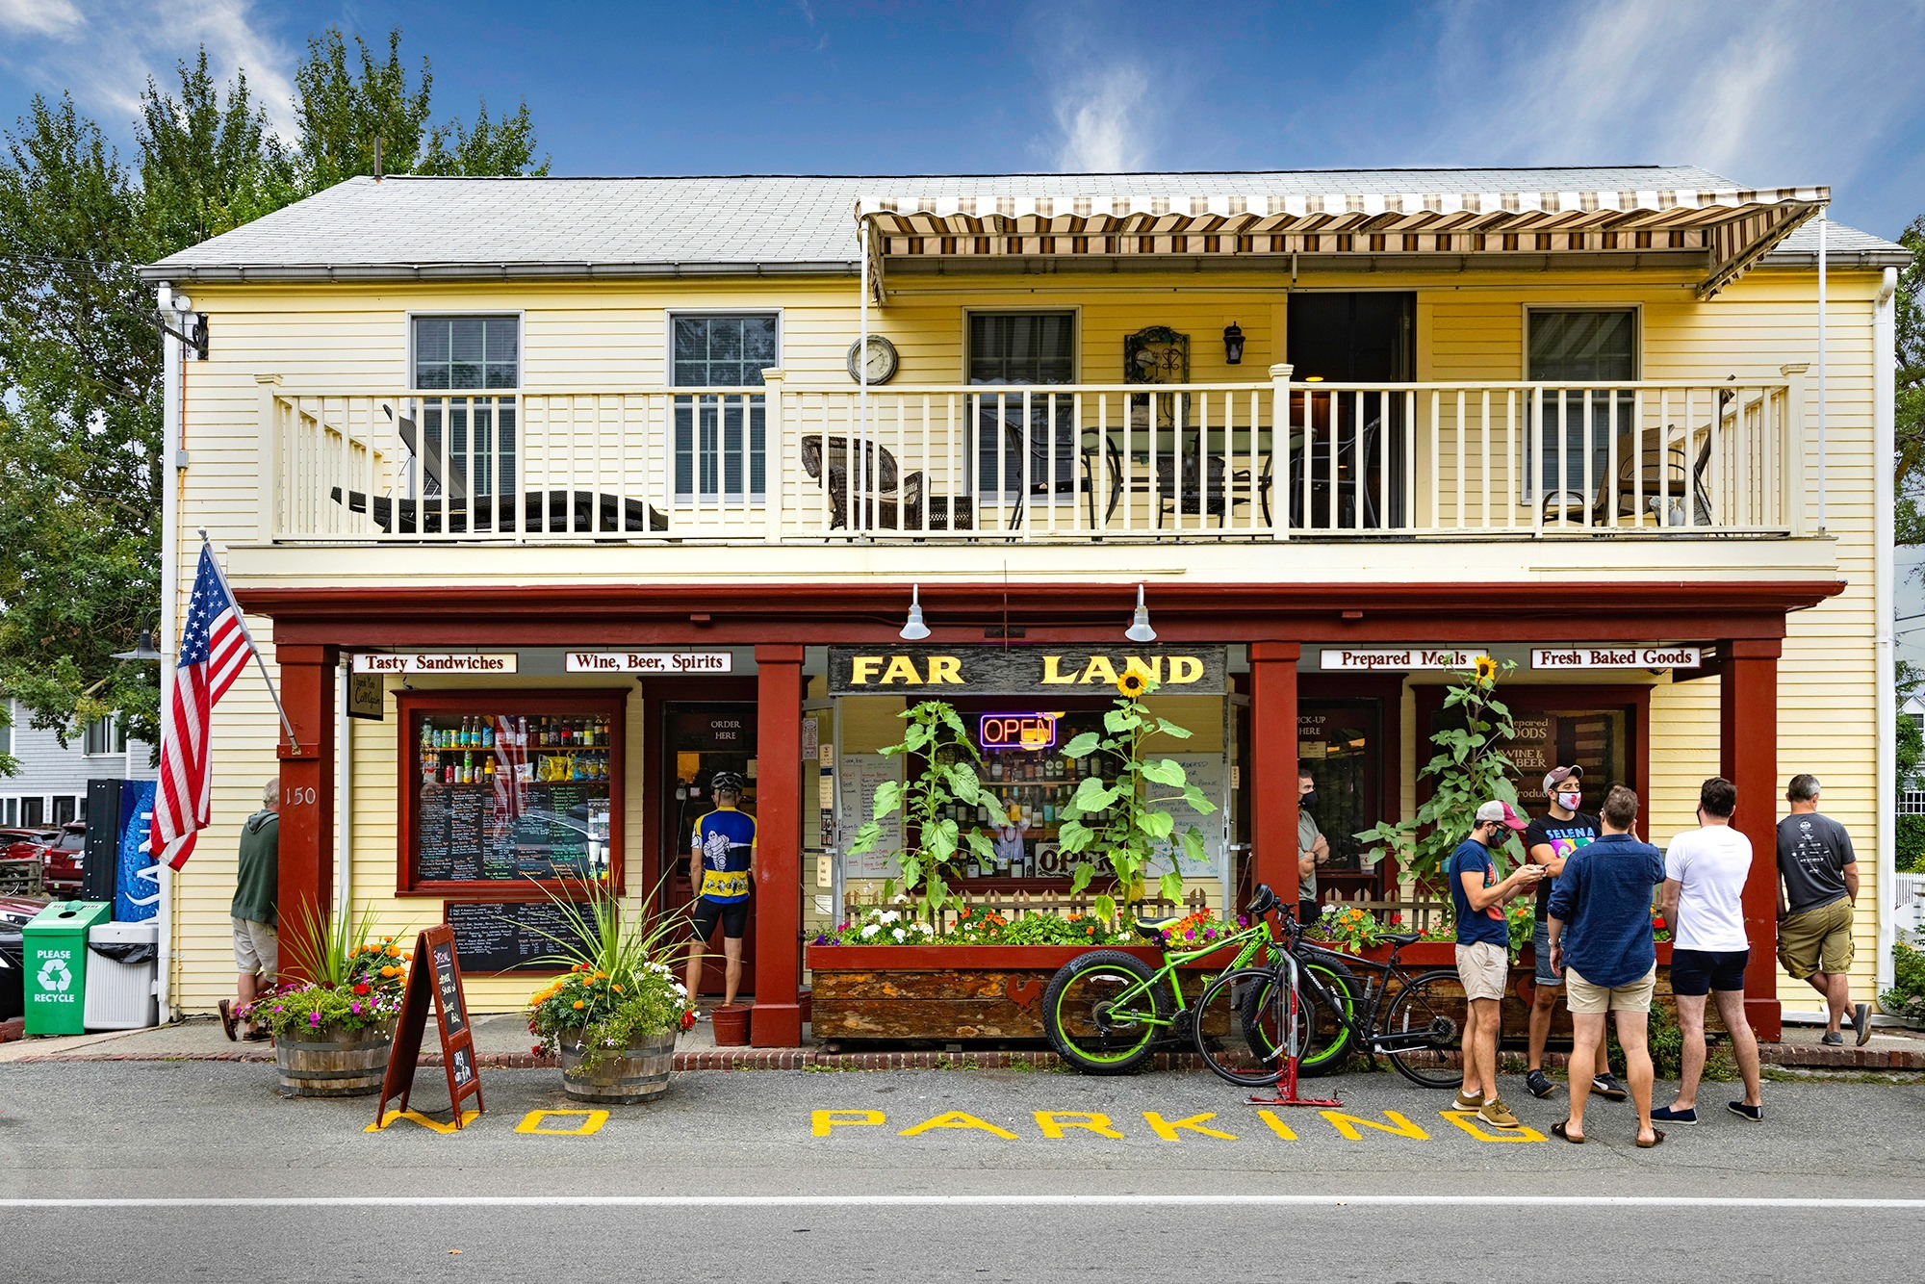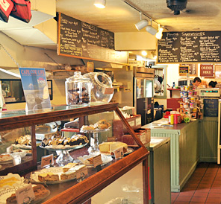

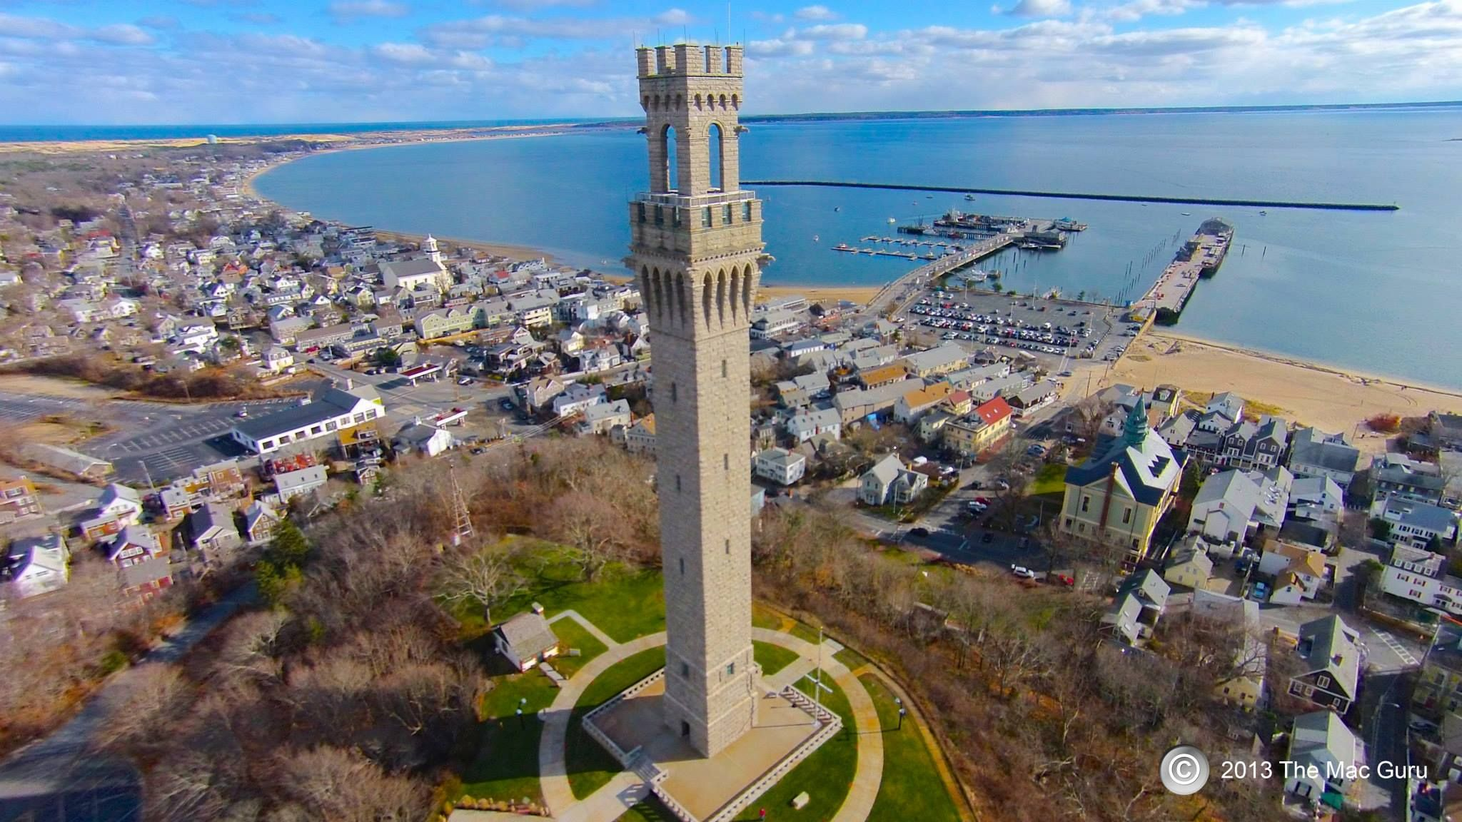

Employer info: |  | A locally well known family owned and operated business: quality deli/ bakery and grocery all under one roof.
Location info: |  | Provincetown, MassachusettsTTT https://ptownchamber.com/  It is a small New England coastal town located at the tip of the famous Cape Cod . It is a popular summer, sandy beach vacation destination on the coast of the Atlantic Ocean. There are plenty events, things to do and see here in the summer (museums, fairs, concerts, biking, hiking, sailing, whale-watching). It is located – 1,5h from Boston (by ferry), 2,5h from Providence and 5h from NYC (by train + ferry).
Average h/week: |  | 35+
Overtime: |  | If available paid 150% , but company tries to avoid overtime
Position: | Job title: | Deli Clerk
Position: | Salary/h: | $15 + tips (total average with tips over $22 - 25/h)
Position: | Start/ end dates: | 25.05 – 23.06 to 09 - 30.09
Position: | English knowledge: | Very good English and communicational skills.
Position: | Additional work info: | Takes customer orders, makes sandwiches, operates cash register, does preparations in deli, cleans-up.

Bonus/ benefits: | - FREE meal while working with 15 minute paid break  - 20% discounts on purchases  - Employee staff party/boat cruise at the end of season.
Additional Employer info: | - you will be paid weekly  - 3 day training required, but paid for (excluding tips).  - Far Land closes every day by 6pm so second jobs are easy to arrange after hours.  - Work T-shirts provided  - Must demonstrate proper hygiene, no perfume.
Housing info? | - YES;  - $200/week/person. Rooms shared by 2. All fees included in weekly cost  - Housing is co-ed (one room for a couple = double bed; 2 rooms with 2 single beds each)  - Located 1 mile from work so you walk or bike to work  - Deposit $500.



